**CODE PLAN**

**Breakdown:**

**The black box will be proprietary and run once Power ON is activated. An LED array will show the black box has power and also functions as a backlight for the biker. Movement on the bike will be recorded from the accelerometer to indicate when a dramatic change in acceleration is found. A possible gyro could be added to refine information to when the bike is at an extreme angle in either direction. Information will be constantly sent or written to an SD card for later review. Speed and deceleration can be seen from SD card reading.**

**Components:**

*LED Array:*

* *Loops through selected patterns*
* *Ability to change LED pattern to fit needs (i.e. blinking X as bikes backlight.*
* *(working on button press for on and off)*

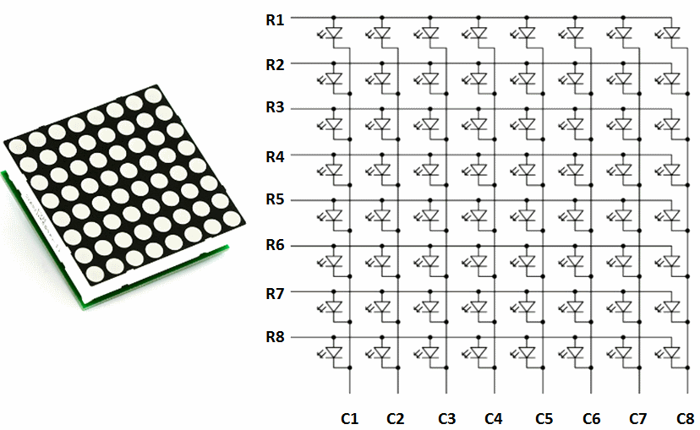

*Accelerometer:*

* *Records starting and stopping accelerations throughout bike ride.*
* *Sends information to SD card to be saved for later recovery.*

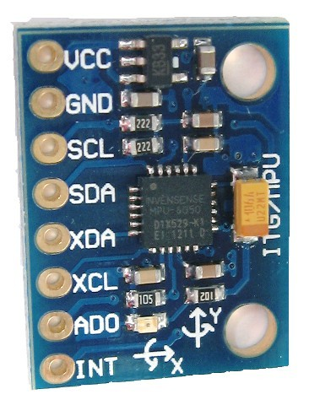

*SD Card/Reader:*

* *Pulls information from accelerometer and saves to card.*
* *SD Reader is attached to arduino to route information.*
* 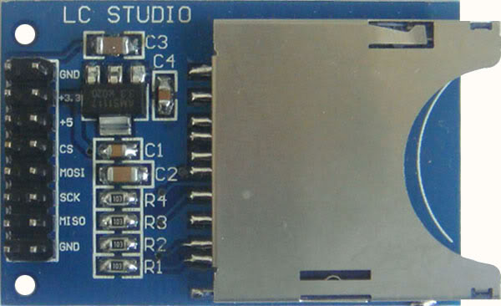

*Gyroscope (*Possible*):*

* *May be used to refine information for when bike is flipped or on its side at a certain angle.*

**

*9v Battery Adapter:*

* *Powers arduino*

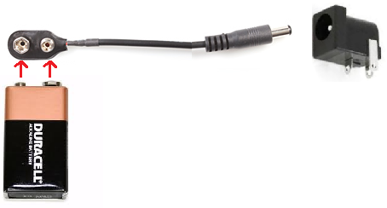

**Pseudocode:**

* ***Array***
  + *Turn on arduino*
  + *Uploaded pattern will display.*
  + *ON/OFF option for array.*
* ***Accelerometer***
  + *Read information once trip has begun.*
  + *Filter written information* ***if gyro is added***
  + *Write information to SD card through reader*
* ***SD/READER***
  + *Read information given once sent from accelerometer*
  + *Write to SD card*

*.*